

1 General 2
1.1 What is a GCCH environment? 2
1.2 When will the migration be complete for all in-scope employees? 2
1.3 How will I know when my migration will occur? 2
1.4 What can I do to prepare for the migration? 2
1.5 What is changing for me? 2
1.6 What will I need to do after my data migration is complete? 2
1.7 What are the expectations following Cutover Weekend? 3
1.8 How do to access Commercial while on GCC High device? 3
1.9 How will I log in to the Serco GCCH tenant? 3
1.10 What if I am on vacation during my migration window? 3
2 Outlook 3
2.1 What is being migrated over and what is not? 3
2.2 During UAT, why am I not seeing my most recent data? 3
2.3 During UAT, why am I unable to see my Calendar in Outlook? 4
2.4 What happens to calendar invites? 4
2.5 Will my signature migrate? 4
2.6 Do rules I have for my clients get migrated? 4
2.7 How can I save and re-import my Personal Address Book (PAB)? 4
2.8 What happens to my encrypted messages? 4
2.9 How do I change settings for Auto Reply and Auto Forwarding? 4
2.10 Even though I’m using my Serco GCC High email, will my Commercial email address still be visible to in the address book? 5
2.11 Changes to my Serco Commercial calendar invites are not showing in my Serco GCC High calendar. 5
3 Teams 6
3.1 What is being migrated over and what is not? 6
3.2 My Teams sites have not migrated? 7
3.3 What is the best practice for monitoring both Serco Commercial and Serco GCC High Teams? 7
4 SharePoint 7
4.1 What is being migrated over and what is not? 7
4.2 How long will the SharePoint sites remain active in Serco Commercial environment? 8
4.3 My SharePoint sites have not migrated? 8
4.4 How do I share a file or folder? 8
4.5 How do I sync my SharePoint library to OneDrive? 11
4.6 How do I check-In checked-out files? 11
4.7 How do I transfer Power Platform from Serco Commercial to Serco GCC High? 11
5 OneDrive 11
5.1 What are the file types restricted in Serco environment? 11
5.2 What is being migrated over and what is not? 11
5.3 How do I find out how much data I have in OneDrive? 12
6 OneNote Notebooks 12
6.1 OneNote – Personal 12
6.2 OneNote – Shared 12

General

What is a GCCH environment?
GCC High, or Microsoft 365 Government Community Cloud High, is a specialized cloud environment designed by Microsoft for organizations handling sensitive government data. It provides a more secure environment than the standard Microsoft 365 GCC by offering features like enhanced security, data residency within the US, and restricted access to cleared personnel.

When will the migration be complete for all in-scope employees?
You will move to the new tenant before June 2026.

How will I know when my migration will occur?
Migration waves are determined by the Business Unit or Function that you support. Visit the GCC High Migration Hub for an overview of the migration wave timelines.

What can I do to prepare for the migration?
There are some actions you need to take to prepare for the migration. These include:
- During the cutover periods, we ask that all employees not log into any M365 applications.
- For Email: Be sure to update your email signature to inform and direct customers to your serco-na.us GCCH email.
- For SharePoint: Check in all checked out files (see section 4.5 of the Migration FAQs).
- For all Applications (Email, OneDrive, SharePoint, and Teams): Please refrain from deleting content, renaming folders or moving content.
- If you have any PST files, we ask that you manual .zip file them and move them into your Commercial OneDrive prior to migration. You will need to move them out of GCC High OneDrive immediately following migration.

What is changing for me?
You are migrating to the GCCH environment, your new Primary email address will be Firstname.Lastname@Serco-na.us. You will still use your Serco-na.com (Commercial) for Timekeeping, HR, benefits, training, etc.

What will I need to do after my data migration is complete?
Once your migration is complete, you should validate that all of your M365 data has been moved over:
- Email: Verify you have access to your contacts, calendar, emails and tasks within Outlook.
- OneDrive: Confirm files and folders have been copied over to the environment.
- SharePoint: Verify you have access to all your sites and verify the item count. You can verify the SharePoint site mapping one-week prior to migration by visiting the Migration Registry at GCC High Migration Registry - Home https://serco.sharepoint.com/sites/GCCHighMigration/SitePages/CollabHome.aspx.
- Teams: Confirm your access to all teams and channels. You can verify the Teams site mapping one-week prior to migration by visiting the Migration Registry at https://serco.sharepoint.com/sites/GCCHighMigration/SitePages/CollabHome.aspx

If you experience issues, work with the Technology Migration Team during the Hypercare period.

What are the expectations following Cutover Weekend?
Emails will be delivered to your Commercial email and forwarded to your GCC High email. Emails in your Commercial account will be read-only so you will be unable to send emails and invites. OneDrive and SharePoint Commercial sites will be in read-only.

How do to access Commercial while on GCC High device?
When on your GCC High device, open a MS Edge private browser and go to Office.com. This will allow you to access your Commercial needs along with any SharePoint/Teams sites that have not migrated yet.

How will I log in to the Serco GCCH tenant?
You will sign in with your Serco GCCH email address. This will follow the same format as your commercial account but will end in Serco-na.us. For example, Firstname.Lastname@Serco-na.us.

What if I am on vacation during my migration window?
You must inform your manager and leadership of your Out of Office dates- failure to do this will result in work stoppage. When you return, you will begin working from your new Serco GCC High environment/workspace.

Outlook

What is being migrated over and what is not?

Migrated | Not Migrated
- Inbox  - Drafts  - Deleted Items  - Archive  - Folders  - Email Contacts  - Calendars  - Tasks  - Flags/Categories/Sensitivity  - Distribution Groups  - Shared Mailboxes | - Deleted Contacts  - Deleted Tasks  - Junk email  - Rules. See Section 2.4 for details  - Signatures  - Custom Views  - Pinned Folders  - Custom Settings  - Mobile Device Sync  - Send-As/Send-on-Behalf

During UAT, why am I not seeing my most recent data?
The migration team will run a pre-sync of your data before cutover weekend to start syncing the older content. Your newer content can be seen in GCC High following cutover weekend.

During UAT, why am I unable to see my Calendar in Outlook?
Calendars will not be synced until cutover weekend to avoid potential duplicity errors. The Monday following cutover weekend all calendar items should be visible.

What happens to calendar invites?
Once your Wave is done, Employees will need to recreate and re-coordinate meetings in the new Serco GCC High tenant. Inform coworkers and external meeting organizers to include your new GCCH Serco-na.us email. See section 2.4 of this document for further details. Please note that calendars will not be synced for the user acceptance validation week, they will only be synced during your migration cutover weekend to avoid duplication.

Will my signature migrate?
No. We recommend following these instructions to set-up your new Serco signature. How To Add or Edit Email Signature.

Do rules I have for my clients get migrated?
Outlook Rules will not be migrated. As part of the validation process, you should prepare to re-create the rules on your Serco Outlook profile.
You may need to Export and then Import any rules you have by following the instructions located here.

How can I save and re-import my Personal Address Book (PAB)?
We recommend you save your PAB to OneDrive so it can be easily transferred back after the migration.

What happens to my encrypted messages?
Encypted emailed will be migrated from your commercial environment to your GCC High environment. No action needed

How do I change settings for Auto Reply and Auto Forwarding?
If you would like to set your own forwarder please follow these instructions: Turn on automatic forwarding in Outlook - Microsoft Support
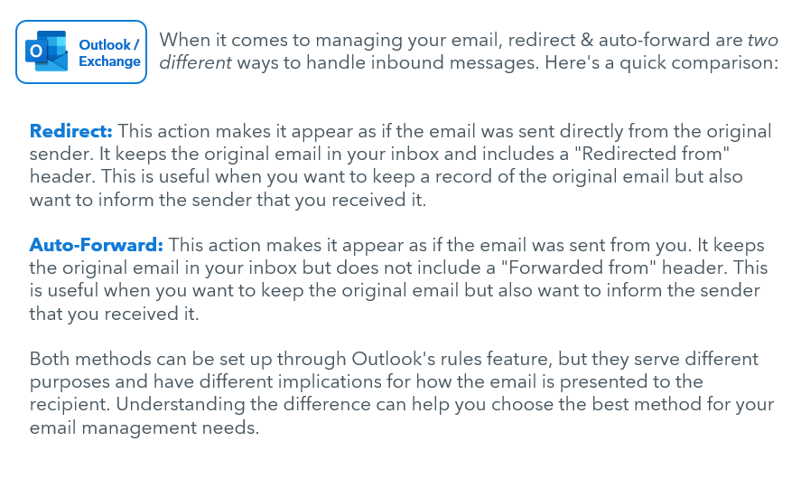

Even though I’m using my Serco GCC High email, will my Commercial email address still be visible to in the address book?
If you are in your GCC High environment, you will only be able to see others GCC High contact information in the global address book. If you want to see employee commercial email addresses, you will have to save them as a contact.

Changes to my Serco Commercial calendar invites are not showing in my Serco GCC High calendar.
After migration, changes to your existing data will not sync to your Serco GCC High calendar. If you need to make changes to a calendar object that is hosted on the Serco Commercial calendar, we recommend the following based on each scenario:

If you are the migrated meeting owners: Access your Serco Commercial mailbox calendar using the attached instructions, “Access Serco GCC High Email Through Office.com”. Locate the invitation, appointment or event. Keeping the Serco Commercial invitation open, open your Serco GCC High calendar on your desktop. Copy and paste the text and attachments of the Serco Commercial invitation into a new Serco invitation. If this is a Teams meeting, be careful to copy just the text- skip the Teams invite codes and meeting links. The original Serco Commercial Teams invite codes and Serco Commercial Teams meeting links will no longer be valid after the migration is finished. When done, Cancel the calendar object on your Northrop Grumman calendar and Send the new series from your Serco calendar.
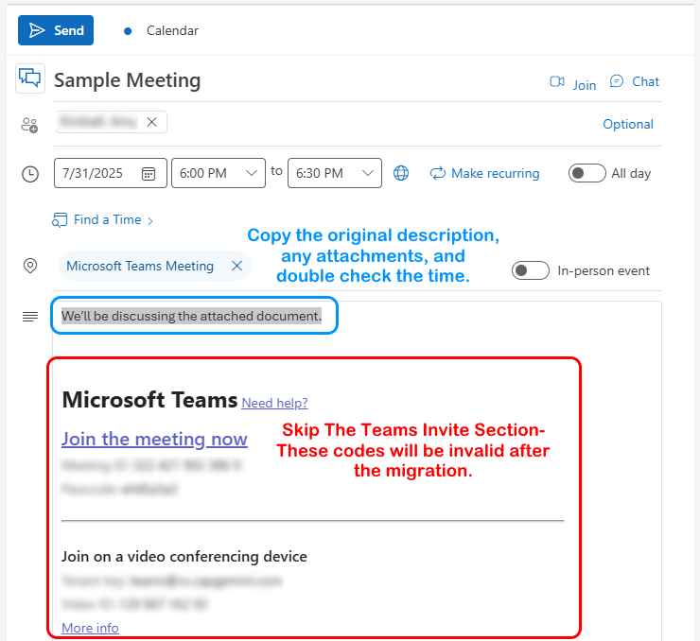

If you are not the meeting owner, you will not need to make any changes as the invite will be migrated along with the rest of your calendar items.
*Note: All new, post-migration, invites must be sent to your Serco email address.

Teams

What is being migrated over and what is not?

Migrated | Not Migrated
General:  - Permissions  - Migrated teams may not appear in the same order. User may drag and drop to reorder the lists. | General:  - Teams settings such as Logo  - Planner  - Apps not yet approved by Serco (prior to migration, users were asked to inform their business champions of any applications they are using)  - Custom tags for teams
Files:
- Files in public teams and channels
- Files in private channels
Channels:  - Standard channels  - Private channels | Channels:  - Shared channels: Shared Channels can only be provisioned in the original team where the channel was created. Shared Channel membership is not migrated.
Conversations:  - Messages  - Chats within meetings and channels will migrate and be available for UAT.  - Replies  - Formatting - fonts, bullets, lists, colors  - Quotes  - Inline images & stickers  - Hyperlinks  Mentions (as plain text)  60 days of One-on-One Chats | Conversations:  - Emojis & GIFs  - Tags  - Likes & reactions  - Links to files and meeting requests  - Files previews  - Hyperlink previews  - Teams meeting invites in conversations  Teams recordings  Rich card attachments  Favorites or Pinned Chats  - Messages  - 1-on-1 Chats with other people outside of meetings and channels (includes chats with multiple users) will be available post cutover only.
Tabs:  - Posts  - Files | Tabs:  - Flows  - Streams  - Forms  - Folders from Cloud storage  - OneNote  - Custom Tabs
Others:  - Contacts  - Categories | Others:  - Bots  - Custom tags for teams  - Wiki sections and pages

My Teams sites have not migrated?
The Business Champions are approving of what sites are migrated when. Please reach out to your Business Champion to inquire on your site migration.

What is the best practice for monitoring both Serco Commercial and Serco GCC High Teams?
As a migrated user, we recommend you set your Serco Commercial Teams offline / Out of Office (OOO). Let them know where they can reach you on the Serco GCC High side via email and where applicable, your Serco GCC High Teams Telephony number. Click here for instruction to set your status message in Teams.

If on Desktop, we recommend opening the opposite account in your web browser. You can do so by going to Office.com.

SharePoint

What is being migrated over and what is not?

Migrated | Not Migrated
- Document libraries  - Lists  - Surveys  - Permissions  - Versioning  - Metadata  - Site Pages (Classic & Modern)  - Site logos and customization  - Images  - Videos  - Audio Files  - Site content types  - Site columns  - Sub-sites (when enabled at the target Tenant)  - Navigation and navigation elements  - List templates  - Term store (partial)  - List and library Audience targeting settings  - List views (partial) | - Site page headers and footers  - Document library item highlighting/pinning  - Document library sensitivity labels  - Task lists  - Custom task  - Shared permissions for files/folders with symbols in name  - Alerts  - Content type hub  - Forms for lists  - Document library sensitivity labels  - List rating settings  - Audience targeting settings  - Microsoft Forms  - SharePoint 2010 workflows  - Workflow instances  - Checked out status for files  - Files with no checked in version  - Private views  - Classic web parts in classic wiki pages  - Comments on modern site pages  - InfoPath Forms  - Power Apps  - Power Automate flows

How long will the SharePoint sites remain active in Serco Commercial environment?
Post migration your SharePoint site will go into read-only mode and it will be soft deleted to a Recycle Bin after 3 weeks.

My SharePoint sites have not migrated?
The Business Champions are approving of what sites are migrated when. Please reach out to your Business Champion to inquire on your site migration.

How do I share a file or folder?
- On your SharePoint site, go to the library where you want to share files.
- Pick the file or folder you want to share by selecting its circle icon.
Note: Sharing multiple items at the same time is not available. Instead, you can add the things you'd like to share to a folder and then share the folder.
  - If you're using List view, select the circle on the left side of the item.
  - If you're using Tiles view, select the circle in the top right corner of the item.
- Select Share at the top of the page.
Notes: If the selected file or folder is shared with someone already, there is a Shared with list at the bottom. Each image is either the profile photo of an individual or the initials of a group that the file has been shared with. If you want to edit the access level for an individual or group, select a photo or group initials to open Manage Access.
- If the selected file or folder isn't currently shared with someone, there won't be a Shared with list.
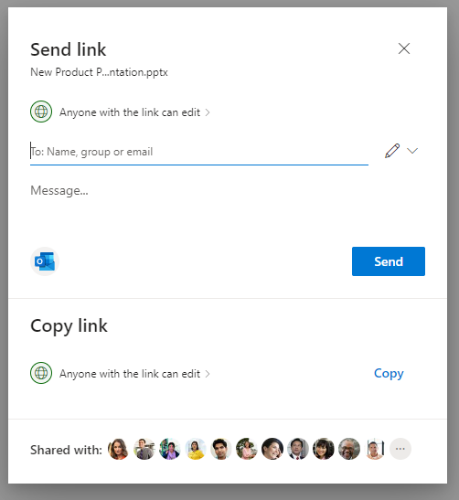

- Under Send Link, select Anyone with the link can edit to open the link settings.
Note: Depending on settings set by your administrator, you may have different default settings. For example, this button could say People in <Your Organization> can edit.
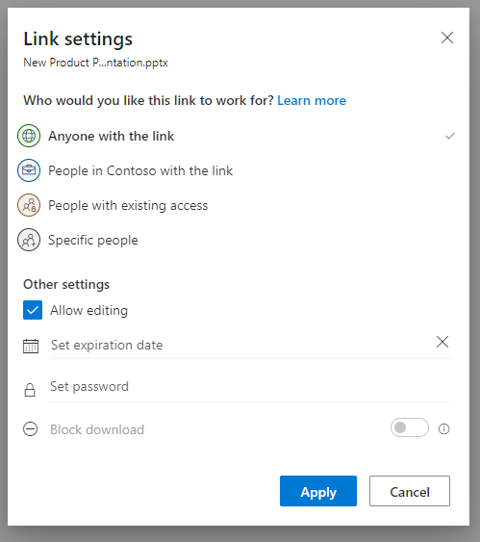

- Select an option for who you want to give access to with the link:
Notes: If a sharing option has been greyed out, your organization's admins may have restricted it. For example, they may choose to remove the Anyone option to prevent usable links being forwarded to others outside your organization.
To track access and ensure security, you can only share with someone who is in your organization or has a Microsoft Account.
  - Anyone gives access to anyone who receives this link, whether they receive it directly from you or forwarded from someone else. This may include people outside of your organization.
  - People in <Your Organization> with the link gives anyone in your organization who has the link access to the file, whether they receive it directly from you or forwarded from someone else.
  - People with existing access can be used by people who already have access to the document or folder. It does not change any permissions. Use this if you just want to send a link to somebody who already has access.
  - Specific people gives access only to the people you specify, although other people may already have access. If people forward the sharing invitation, only people who already have access to the item will be able to use the link.
- Under Other settings, you can set any of the following options:
  - Allow editing lets people who are signed in with a Microsoft Account edit the files or folders they have access to. If you're sharing a folder, people with Edit permissions can copy, move, edit, rename, share, and delete anything in the folder they have access to. Unchecking this box means that people can view, copy, or download your items without signing in. They can also forward the link to other people. However, they cannot make changes to the version on your SharePoint.
Notes: Allow editing is turned on by default.
  - You can also set editing permissions on the previous screen. Under Send link, next to the Name, group or email field, select the pencil icon to change the editing permissions for the people or groups you have entered.
  - Block download prevents people from downloading the file or folders they have access to. Unchecking this box means that people can download the files onto their devices.
Note: This option is only available if you don't allow editing.
  - Set expiration date lets you set a date for the link to expire. After the date you set, the link won't work and you will need to create a new link for users requiring access to your file or folder.
  - Set password letsyou set a password to access the file. When a user opens the link, they will be prompted to enter a password before they can access the file. You'll need to provide this password separately to anyone you want to share the file with.
  - Open in review mode only limits people to leaving comments and making suggestions on the file.
Notes: Only Word documents / files have this permission option.
  - If someone already has editing permissions for the document, selecting Open in review mode only will not prevent them from making edits. For them, the document will open in edit mode.
- Once you have set all your link settings and permissions, select Apply.
- In the Name, group or email field, start typing the email addresses or contact names of people you want to share with. When you begin to enter info in the box, you can also choose a contact from the list that appears.
Tip: To quickly share with specific people, you can type in their name or email and then use the pencil icon to the right of the Name, group or email field and select Can edit or Can view. Then follow the same steps below to share with the specific people you listed.
- Include a message below the Name, group or email field, if you want.
Note: If you want to compose your message in Outlook, select the Outlook button and the link will be inserted into a draft email and everyone you entered to share with will be in the To / Recipient list.
- Select Send. D

How do I sync my SharePoint library to OneDrive?
- In your browser, on your SharePoint site, navigate to the library of files you want to sync with.
- Select Sync in the toolbar.
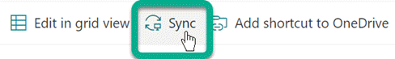
Note: If your browser asks for permission to use OneDrive, confirm that it's OK.
- Sign in to OneDrive to start syncing your files and finish OneDrive setup.

How do I check-In checked-out files?
1. Access Document Library Settings: Go to the document library in SharePoint where the files are located. Click on the gear icon (Settings) and select "Library settings".
2. Locate "Manage files which have no checked in version": Under the "Permissions and Management" group, find and click on the link "Manage files which have no checked in version".
3. Take Ownership: If you are not the original uploader, you may need to take ownership of the files. Select the files you want to check in and click on "Take Ownership of Selection".
4. Check In the Files: After taking ownership, the files will be available in the document library. Go to the library, select the files, and click "Check in".
5. Provide Metadata (if required): You may need to provide metadata or a check-in comment before the files are fully checked in.

How do I transfer Power Platform from Serco Commercial to Serco GCC High?
Site owners are expected to migrate their own Power Platform components using these instructions. If you have any questions or need any additional support please open a ticket with the help desk. Click here for instructions on each of the Power Platform solutions.

OneDrive

What are the file types restricted in Serco environment?
None

What is being migrated over and what is not?
Migrated | Not Migrated
- Folders  - Shared Folders  - Permissions  - Code Files  - Documents  - Images  - Forms  - Executables  - Videos  - Audio Files  - Version history | - Links (to OneDrive files) giving access. Users will have to re-share links

How do I find out how much data I have in OneDrive?
To find your OneDrive data size, follow these steps:
- Go to Office.com
- Click on Apps > OneDrive
- Click on the Gear/Settings Icon in the top right
- Click OneDrive Settings
- Click More Settings on the left
- Click Storage Metrics
- The Size is calculated in the top right.

OneNote Notebooks

OneNote – Personal
If you use OneNote, follow the steps below to ensure your data is migrated:

- Open your OneNote application. Click on File, then Info, then Settings, and then select Properties - as seen below.

- In the “Notebook Properties” screen, click on “Change Location” button.

- In the popup, expand the OneDrive – Serco folder, then navigate to Documents >> OneNote Notebooks, if it exists. This will be the location your OneNote workbook will be saved to. If the OneNote Notebooks folder does not exist, then create or select another location of choice within the OneDrive – Serco folder. Click “Select” to finalize the folder selection.
- Once the OneNote Notebooks is moved to the new location, you get a notification as seen below. Click OK to finalize the configuration.
- To confirm the change just made, click on File then Info. The path to your OneNote file should now reflect the URL https://serconagcch-my.sharepoint.us/personal/... Path.

OneNote – Shared

- Refer to Steps 1 and 2 in the previous OneNote section.
- In the pop-up, paste the destination URL where the OneNote should be stored, such as a SharePoint site.
- Once the OneNote Notebooks is moved to the new location, you get a notification as seen below. Click OK to finalize the configuration.
- To confirm the change just made, click on File then Info. The path to your OneNote file should now reflect the destination URL you selected in Step #3

